|  |  |
| --- | --- |
| **ATUL Ltd.** |  |

**ATUL Ltd.**

**Internship Report**

*Submitted by*

**Kanishq Sahu (2022CHB1049)  
IIT Ropar**

**2022chb1049@iitrpr.ac.in**



*Supervised By*

***Mr. Jayesh Patel***

1 Aim of the Internship: 3

2 Theory learned: 3

Active Pharmaceutical Ingredient (API) and Excipients 3

API (Active Pharmaceutical Ingredient): 3

Excipients: 3

Raw Materials, API and Drugs 4

Difference: 4

Types of Reactors (Chemical Aspect) 4

3 PROJECT 1: Design of Condensers for Chemical Plant: 16

4 PROJECT 2: Design of Main Steam Meter for Chemical Plant 19

5 Project 3: Piping and Instrumentation Diagram (P&ID) - G-2128 Reactor MSGL 24

6 PROJECT- 4: Reducing Distillation Timescale 29

7 Departments at Atul Limited 33

8 Report: Study Intelligent Plant Framework (IPF) Implementation at Atul Ltd. 36

9 BTG proposal for Atul's 100 TPD Caustic Plant digital optimization project: 50

10 Acknowledgments: 2

11 References: 3

# Aim of the Internship:

The aim of the internship was to gain practical experience in the field of chemical engineering, focusing on the design, optimization, and implementation of essential unit processes and process equipment in a chemical plant. This involved applying theoretical knowledge to real-world scenarios, enhancing problem-solving skills, and contributing to the efficiency and safety of plant operations.

# Theory learned:

## Active Pharmaceutical Ingredient (API) and Excipients

## API (Active Pharmaceutical Ingredient):

* The biologically active component of a drug product.
* Produces the intended effects in medications.
* One of the two main ingredients in medicine, alongside excipients.

## Excipients:

* Inactive substances used as vehicles or mediums to deliver APIs.
* Serve various purposes:
* Stabilization
* Physical Form
* Dosage Form
* Taste-Masking
* Enhanced Delivery
* Coloring and Flavouring

Common excipients include fillers, binders, lubricants, disintegrants, preservatives, coatings, and solvents.

## Raw Materials, API and Drugs

## Difference:

* Raw materials are base chemical compounds used to make APIs.
* API manufacturers procure raw materials to produce active components.
* APIs denote the dosage in a drug, while finished formulation is the process of mixing chemicals to create specific drugs.

## Types of Reactors (Chemical Aspect)

**Overview:**

* Reactor selection crucial for systematic conversion of reactants into products.
* Types selected based on expected outcome, operating conditions. 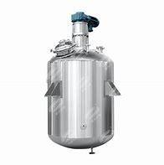

**1. Batch Reactors:**

* Reaction take place batch wise, where raw material are charged to give desired batch output.
* Used frequently in pharmaceutical industries.
* Advantages: Uniform composition, cost-effective, no contamination from previous batch after cleaning.
* Limitations: Requires tight temperature control, quality variation between batches.

**2. Continuous (Steady-State) Reactors:**

* Reactant addition and product removal occur simultaneously.
* Maintains constant reaction level.
* Commonly used in chemical process plants.
* Advantages: Steady-state operation, optimum quality parameters.

**3. Tubular/Plug Flow Reactors (PFRs):**

* Cylindrical tubes carry out reactions.
* No axial mixing, less volume required for same conversion.
* Efficient for positive order reactions.

**4. Catalytic Reactors:**

* Involves heat transfer, mass transfer, and catalysts.
* Types include Fixed Bed, Trickle Bed, and Fluidized Bed reactors.
* Applications: Chemical synthesis, polymerization, hydrogen cracking.

**Pharmaceutical Classification:**

**Based on Material of Construction:**

* 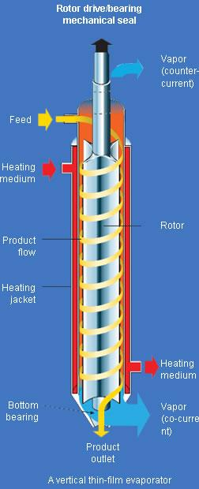Stainless Steel Reactors (SSR)
* Glass Lined Reactors (GLR)
* Selection based on process pH:
* Acidic (<7): GLR
* Alkaline (>7): SSR
* Neutral (=7): SSR

**Autoclave Reactor:**

Used for high-pressure and high temperature reactions

**Agitated Thin Film Evaporator (ATFE)**

* ATFE offers a one-step operation for evaporating volatile components from viscous products.
* Low residence time minimizes thermal degradation, making it suitable for temperature-sensitive materials.
* Features a fully enclosed design, ideal for handling explosive, toxic, or hazardous substances.

**Indirect Contact Evaporation**

* Heat transfer to liquid without direct mixing with heating medium.
* Heat transferred through solid surface, such as walls of a heat exchanger.

**Low Residence Time**

Short duration for liquid heating and evaporation.

**Unit Process and Unit Operation**

* Unit Process: Chemical reactions (e.g., A+B=C+D)
* Unit Operation: No chemical reactions, involves physical changes (e.g., Drying, Filtration).

Examples of Unit Operations:

* Drying
* Filtration
* Distillation
* Crystallization
* Evaporation
* Extraction
* Size reduction
* Scrubbing

**Why is the Glass Lined Reactor Blue?**

* Cobalt composition in glass imparts blue color.
* Blue color exhibits higher thermal conductivity and wider pH acceptance.

**Filtration Techniques**

**ANF (Agitated Nutsche Filter) and ANFD (Agitated Nutsche Filter Dryer)**

* ANF and ANFD are widely used in API pharmaceutical plants for solid-liquid separation and drying processes.
* They feature an agitator mechanism that aids in efficient filtration and drying of the product.
* Suitable for applications requiring a high degree of purity and moisture control.

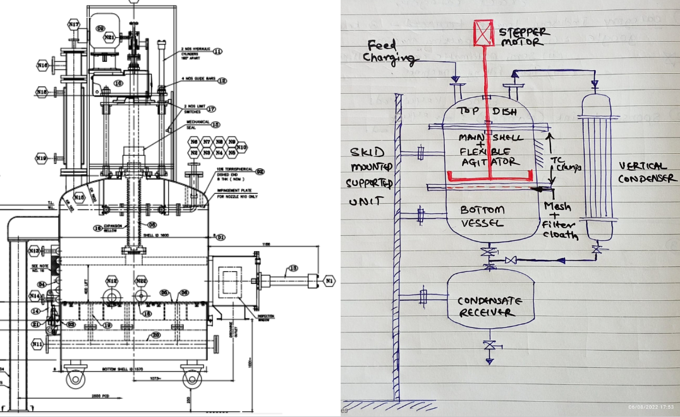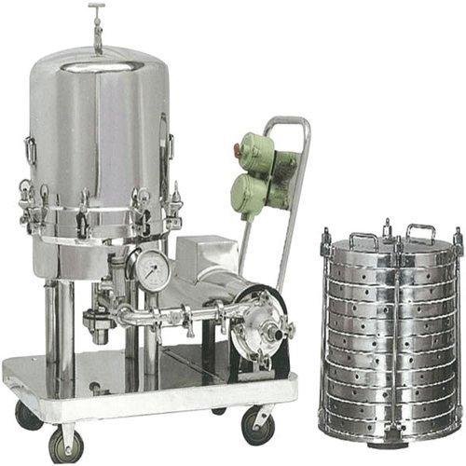

**Sparkler Filter**

* Sparkler filters are utilized for fine filtration of liquids in API pharmaceutical manufacturing.
* They consist of a series of horizontal plates with filter media, ensuring effective removal of impurities.
* Ideal for processes where clarity and purity of the final product are paramount.

**Bottom Discharge Centrifuge:**

* Bottom discharge centrifuges are employed for separating solid particles from liquid suspensions.
* They utilize centrifugal force to achieve rapid and efficient separation.
* Particularly useful for applications requiring continuous operation and high throughput.

**Drying Operations:**

**Fluid Bed Dryer (F.B. Dryer)**

* F.B. dryers are batch dryers commonly used in API pharmaceutical plants.
* They employ hot air or gases to fluidize the product bed, facilitating efficient drying.
* Suitable for heat-sensitive materials and achieving uniform drying.

Air Inlet

Out let hot air

Blower

Heating Coil

Air silcone tube gasket

**Vacuum Tray Dryer**

* Vacuum tray dryers are batch dryers utilizing hot water as the heating medium.
* They are characterized by manual handling and are prone to product lump formation during drying.
* Suitable for small-scale production and applications where product integrity is crucial.

**Size Reduction Operations**

**Objective of Size Reduction:**

* Enhances appearance, increases surface area, and improves absorption in pharmaceutical formulations.
* Ensures content uniformity, uniform flow properties, and effective drying during subsequent processing.

**Size Reduction Equipment:**

* Multimill, Hammer mill, Ball mill, Roller mill, etc., are commonly used for size reduction in API pharmaceutical plants.
* 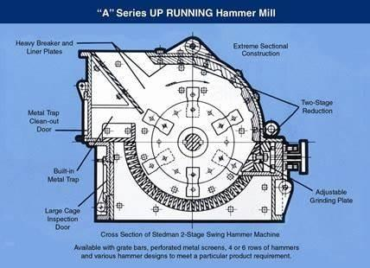These equipment utilize mechanical forces to reduce large solid unit masses into smaller particles.

**Hammer Mill (Micro):**

* Operates on the principle of impact, featuring horizontally or vertically fitted hammers made of hardened steel.
* Rotates at high speeds (8000 to 15000 rpm) to achieve efficient particle size reduction.
* Suitable for a wide range of materials due to adjustable hammer configurations.

**Pharmaceutical Pilot Plant Operations:**

**Introduction:**

The pharmaceutical industry utilizes pilot plants as an essential component in the transition from laboratory-scale formulations to viable commercial products. This report delineates the key aspects of pilot plant operations, including equipment, utilities, scale-up processes, and the product life cycle.

**Pilot Plant Overview:**

**Definition:** A pilot plant represents a crucial intermediary stage wherein lab-scale formulas are transformed into practical manufacturing procedures, serving as a pre-commercial production activity.

**Function:** It bridges the gap between research and production, enabling the development of scalable processes for manufacturing pharmaceutical products.

**Objectives:** To identify and rectify potential issues on a small scale before large-scale production, ensuring the production of physically and chemically stable therapeutic dosage forms.

**Scale-Up Process:**

**Definition:** Scale-up involves increasing batch sizes or applying a procedure to different output volumes while maintaining consistency and quality.

**Objectives:** Identify errors at small scales to enhance profitability at larger scales, ensure stability of dosage forms, review processing equipment, establish production guidelines, and evaluate and validate processes.

**Product Life Cycle:**

**Stages:** Development, technology evaluation, scale-up, commercial production, and product discontinuation.

**Purpose:** To progress from initial formulation to full-scale production while maintaining product quality and compliance with regulatory standards.

**Equipment in Pilot Plant:**

1. **Reactors:** Constructed with stainless steel (SS) or glass lining for chemical reactions.

2. **ATFE (Agitated Thin Film Evaporator**): Facilitates low-residence-time evaporation for viscous products, ensuring solvent recovery and temperature-sensitive product handling.

3. **Centrifuge:** Utilized for solid-liquid separation, particularly in processes requiring efficient drying.

4**. ANFD (Agitated Nutsche Filter Dryer):** Combines filtration and drying in a single vessel, enhancing efficiency and reducing manual handling.

5**. Short Path Distillation Unit:** Employed for separating compounds with close boiling points under vacuum conditions.

6. **Autoclave:** Essential for sterilization of equipment and media to maintain aseptic conditions.

7. **Pump:** Used for transferring liquids or slurries within the process.

**Other Important Equipment:**

* Cooling tower, scrubber, steam jet ejector, and water ring pump contribute to environmental control and process efficiency.
* Various pumps, including centrifugal and positive displacement pumps, facilitate fluid transfer within the pilot plant.

**Utilities in Pilot Plant:**

1. **Cooling Water:** Essential for temperature control in reactors and condensers.
2. **Chilled Water:** Utilized for maintaining low temperatures in heat exchangers and reactors( maintain temperature above 10 degree Celsius)
3. **Chilled Brine:** Utilized for maintaining low temperatures in heat exchangers and reactors.( can maintain temperature much less than 0 degree Celsius)
4. **Hot Water:** Employed in processes requiring elevated temperatures.
5. **Steam (LPS, MPS):** Utilized for sterilization, heating, and various other thermal processes.
6. **Nitrogen:** Used for inerting, drying, and conveying purposes
7. **Air:** Used for drying, and conveying purposes.

**Documentation and Compliance:**

1. **Standard Operating Procedures (SOP):** Detailed guidelines for each operational procedure.
2. **Batch Manufacturing Record (BMR) and Batch Cleaning Record (BCR):** Documents detailing production and cleaning processes.
3. **Housekeeping Records:** Maintenance logs and cleanliness records.
4. **Environmental Monitoring:** Regular monitoring of temperature, humidity, and pressure to ensure optimal conditions.
5. **Calibration and Verification Records:** Documentation of equipment calibration and validation.
6. **Material Safety Data Sheets (MSDS):** Information on the safe handling and storage of chemicals.
7. **Good Documentation Practices (GDP):** Ensuring accurate and traceable documentation throughout the manufacturing process.
8. **Tool box training (TBT):** Daily brief safety training.

**Training:**

 Training programs covering cGMP, SOPs, MSDS, safety protocols, and soft skill development to ensure competency and compliance among personnel.

The pharmaceutical pilot plant serves as a vital nexus between research and production, facilitating the development of scalable processes for manufacturing therapeutic products. With comprehensive equipment, utilities, and documentation procedures, pilot plants ensure the production of high-quality pharmaceuticals while adhering to regulatory standards and industry best practices.

**Steam Distillation Process Flow:**

* Steam distillation is a technique used for separating components of mixtures based on differences in their volatilities under the influence of steam.
* Process involves heating a mixture with steam and collecting the volatile components as they evaporate, then condensing the vapours back into liquid form.

**Agitators for Reactor:**

Reactors often require agitation for efficient mixing and heat transfer.

Different types of agitators include:

* High efficiency impeller
* Pitched blade turbine
* Transition flow impeller
* Straight blade Turbine
* Anchor impeller
* 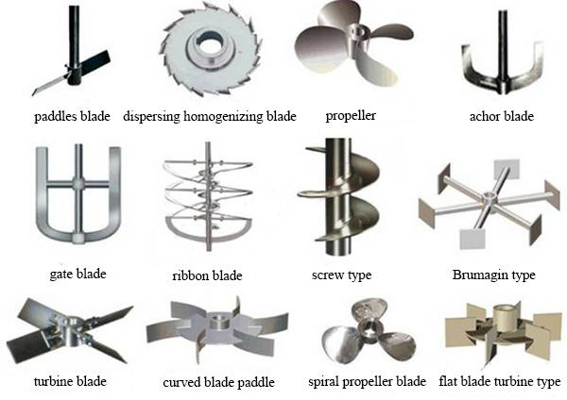Helical ribbon

**Pump Types and Applications:**

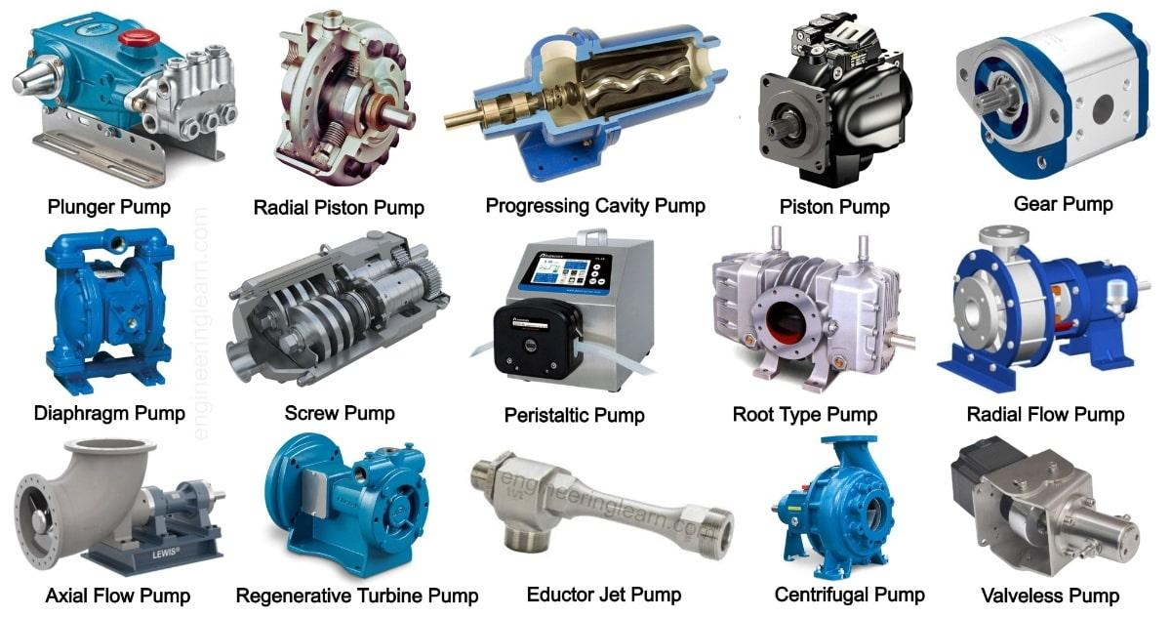

**Centrifugal Pump:**

* Used for high flow-low head applications.
* Commonly used for cooling water circulation, slurry transfer, and process circulation.

**Positive Displacement Pump:**

* Used for low flow-high head applications.
* Types include diaphragm pump, gear pump, screw pump, and piston/plunger pump.

**Pump Materials of Construction (MOC):**

* Solid materials: Carbon steel, stainless steel, Hastelloy, Alloy 20, Titanium, PP.
* Lined materials: PVDF, PFA.

**Pump Operation and Maintenance:**

* Proper priming, venting, and ensuring adequate lubrication are crucial for pump operation.
* Regular maintenance includes checking oil levels, alignment, and flushing lines.

**Causes of Centrifugal Pump Failure and Remedies:**

* Bearing Failure: Due to contamination, heat, or misalignment.
* Remedy: Regular oil checks, proper alignment.
* No Flow: Caused by pump casing blockage, coupling failure, or impeller damage.
* Remedy: Check for blockages, inspect impeller and coupling.

**Heat Exchanger Types and Advantages:**

* Types include shell and tube, plate, and corrugated tube heat exchangers.
* Corrugated tubes offer increased turbulence for higher heat transfer coefficients and reduced fouling.

**Cooling Tower Operation:**

* Cooling towers reject waste heat to the atmosphere by cooling water through evaporation.
* They are essential for maintaining process temperatures in industrial applications.

**Air Compressor Types:**

* Types include reciprocating, screw, and centrifugal compressors.
* Selection depends on pressure requirements and efficiency.

**Importance of Energy Conservation:**

* Emphasizes the significance of conserving energy resources to reduce costs and environmental impact.
* Highlights the need for efficient equipment operation and maintenance practices.

**Valve Types and Internals:**

* Various valve types, such as gate, globe, ball, and butterfly valves, serve different purposes in controlling flow.
* Understanding valve internals is essential for efficient valve operation and maintenance.

**Filtration Techniques:**

* Plate and frame filter press is commonly used for separating solids from liquids in pharmaceutical processes.
* Proper sealing and checking for leakages before slurry feed are critical steps in filter press operation.

**Bearing Types:**

Different types of bearings, including ball bearings, roller bearings, and thrust bearings, serve various load and speed requirements in rotating equipment.

# PROJECT 1: Design of Condensers for Chemical Plant:

**Detailed calculations:**

Excel:

<https://1drv.ms/x/c/ef8cc20df54f4245/ESl4GBr8Nv9KmAXa1lezIfYBC_nkTtjY_tFYfHGIt0a_KQ?e=hj8O7y>

Google: <https://docs.google.com/spreadsheets/d/1PR8rCm4jbcZjyKOy5ZkQzTY81QnnxTXw/edit?usp=sharing&ouid=112061776078456726353&rtpof=true&sd=true>

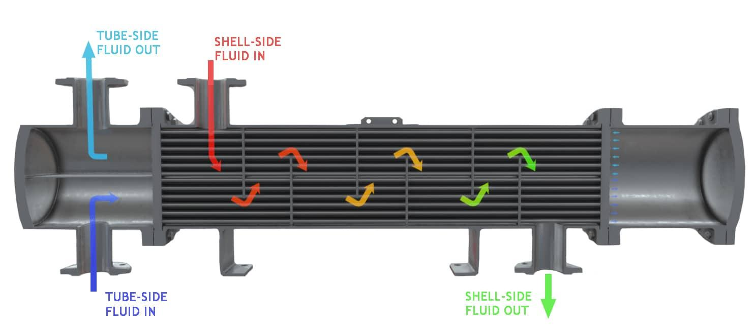

**Introduction**

During my internship at Atul Lt., I was assigned the task of designing condensers ( Primary and Secondary ) for two critical units: an Agitated Nutsche Filter Dryer (ANFD) and a reactor vessel used as a vessel due to the absence of a dedicated condenser. This report outlines the design process, challenges encountered, insights gained, and technical details involved in the design of these primary and secondary condensers.

**Objective**

The primary objective of this project was to design efficient condensers for the ANFD and the reactor vessel to enhance operational safety, improve efficiency in managing vapor emissions, and provide a sustainable solution for the plant's operations.

**Challenges Faced**

**Design Complexity:** Tailoring condenser designs to suit the specific operating conditions and space constraints of both the ANFD and the reactor vessel.

**Material Selection:** Choosing materials that could withstand corrosive chemicals used in processes to ensure durability and operational longevity.

**Integration Issues:** Incorporating condensers into existing equipment setups without disrupting ongoing operations or compromising safety.

**Approach**

**Data Collection:** Gathered operational parameters such as flow rates, temperatures, and vapour types to accurately size the condensers.

**Calculation and Design:** Applied heat transfer principles and engineering calculations to determine the required surface area and configuration of condensers.

**Technical Details:**

**ANFD Condenser Design:**

* Primary condenser designed as a shell-and-tube heat exchanger to cool vapors from the ANFD.
* Secondary condenser integrated as an air-cooled unit to handle peak loads and ensure continuous operation.

**Reactor Vessel Condenser Design:**

* Primary condenser incorporated directly into the reactor vessel for immediate vapour cooling.
* Secondary condenser designed as a water-cooled unit installed externally to manage higher vapour loads and emergency situations effectively.

Here are the Calculations done on Excel:

**Insights and Learnings**

**Practical Application of Engineering Principles:** Applied theoretical knowledge of heat transfer and fluid dynamics to real-world scenarios, enhancing understanding of equipment design and optimization.

**Collaboration and Communication:** Interacted with plant engineers and operators to address operational challenges, incorporating their feedback into the design process.

**Problem-Solving Skills:** Developed skills in identifying and resolving technical challenges through iterative design improvements and practical solutions.

**Observations**

**Operational Efficiency:** Anticipated improvements in energy efficiency and operational reliability with the implementation of new condenser designs.

**Maintenance Considerations:** Emphasized the importance of accessibility and ease of maintenance in the design phase to minimize downtime and ensure continuous operation.

**Conclusion**

The design and specification of condensers for the ANFD and reactor vessel at Pilot and API Plant represent a significant milestone in my internship experience. This project has not only enhanced my technical skills but also provided valuable insights into the complexities of industrial plant operations and equipment design. By addressing specific challenges and applying engineering principles, the condenser designs aim to contribute positively to the plant's efficiency and safety.

**Recommendations**

* Establish regular monitoring protocols to assess condenser performance and ensure optimal operation.
* Consider future expansions or modifications in plant operations to accommodate changing process conditions effectively.

# PROJECT 2: Design of Main Steam Meter for Chemical Plant

**Detailed Calculations:**

Excel:<https://1drv.ms/x/c/ef8cc20df54f4245/EV9VcQY3AdZEpaUiPn-RqZ8Bh2axrAOoVPO6sWwzo3mbdQ?e=Kfazbt>

Google:

[**https://docs.google.com/spreadsheets/d/1wiRtSYHk6f8fVLsOkrb5PFGVBiNNM68n/edit?usp=sharing&ouid=112061776078456726353&rtpof=true&sd=true**](https://docs.google.com/spreadsheets/d/1wiRtSYHk6f8fVLsOkrb5PFGVBiNNM68n/edit?usp=sharing&ouid=112061776078456726353&rtpof=true&sd=true)

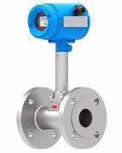**Introduction:**

During my internship , I was tasked with designing a main steam meter to accurately measure peak steam loads for the entire plant. This report details the methodology, analysis, and design considerations involved in creating a robust steam metering solution for two pipeline systems operating at 7.5 kg and 2.5 kg pressures. The objective was to optimize energy management, ensure operational efficiency, and support sustainable practices within the plant.

**Objective**

The primary objective of this project was to develop a comprehensive steam meter capable of monitoring and quantifying steam consumption across diverse utensils (reactors) within the plant. This involved detailed calculations of maximum steam demands from each utensil during peak periods and designing a metering infrastructure that could accurately capture steam flow rates under varying pressure conditions.

**Analysis and Calculations**

**Heat Load Calculation**: Conducted rigorous calculations to determine the thermal load generated by each utensil based on factors such as vessel capacity, operating temperatures, and specific heat capacities of process fluids.

**Maximum Steam Requirement**: Using the heat load data, calculated the maximum steam required by each utensil to establish the sizing and capacity requirements for the steam meter

**Piping and Instrumentation Diagram (P&ID):** Developed a comprehensive P&ID diagram that delineated the entire steam distribution network, including steam generators, pipelines, and endpoints where steam meters would be installed. This diagram served as a blueprint for planning and implementing the metering system effectively.

**Design Considerations**

**Steam Meter Specifications**: Selected appropriate steam meters tailored to the specific requirements of each pipeline system. For the 7.5 kg pressure system, meters capable of handling high-pressure steam flows with precision and reliability were chosen. Similarly, meters designed for lower pressure ranges and sensitive to variable steam qualities were selected for the 2.5 kg pressure system.

**Installation Strategy**: Strategically identified optimal locations within the steam pipeline network for installing steam meters. Factors considered included accessibility for maintenance, proximity to steam generation points, and integration with existing control systems to facilitate seamless data acquisition and analysis.

**Rough Sketch of Steam meter installation place and various steam distributaries:**

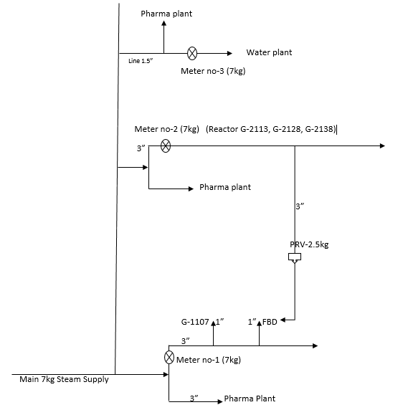

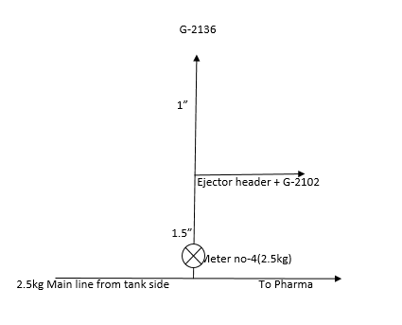

**Technical Details**

**Steam Metering for 7.5 kg Pressure System:**

Implemented high-capacity steam meter equipped to accurately measure steam flow rates under elevated pressures and temperatures.

Considered factors such as flow rate capacity, pressure ratings, and material compatibility to ensure robust performance and longevity.

**Steam Metering for 2.5 kg Pressure System:**

Deployed steam meter optimized for lower-pressure steam applications, characterized by sensitivity to varying steam qualities and flow rates.

Selected meters capable of providing accurate measurements even at lower flow velocities to ensure precise steam consumption monitoring.

Here is the calculation done on Excel sheet:

|  |  |  |  |  |  |
| --- | --- | --- | --- | --- | --- |
| **Steam meter No.** | **Steam Pressure(kg)** | **Pos No** | **MOC** | **Capacity (KL)** | **Temperature Range** |
| 1 | 777 | G-1107 | SS | 2.5 | Upto 100 °C |
| 2 | 7 | G-2113 | SS | 3.5 | Upto 100 °C |
| 2 | 7 | G-2128 | MSGL | 2 | Upto 100 °C |
| 2 | 7 | G-2138 | MSGL | 3 | Upto 100 °C |
| 4 | 2.5 | G-2136 | SS | 1 | Upto 100 °C |
| 4 | 2.5 | G-2102 | SS | 3.5 | Upto 100 °C |
| 4 | 2.5 | Heat Ejector | - | - | - |
| 3 | 7 | G-2221 | SS | 1 | Upto 100 °C |

|  |  |  |  |  |  |  |  |  |  |  |  |  |  |
| --- | --- | --- | --- | --- | --- | --- | --- | --- | --- | --- | --- | --- | --- |
| **Pos No** | **MOC** | **Capacity (KL)** | **Temperature Range** | **Heat load (mL)** | **Boil up** | **T2** | **T1** | **T2 - T1** | **M** | **Cp** | **Mm** | **Cm** | **Q (KCal/hr)** |
| G-1107 | SS | 2.5 | Upto 100 0C | 74918.13726 | 138.7372912 | 100 | **35** | 65 | 3500 | 0.2 | 2000 | 1 | 250418.1373 |
| G-2113 | SS | 3.5 | Upto 100 0C | 112377.2059 | 208.1059368 | 100 | **35** | 65 | 4500 | 0.2 | 2800 | 1 | 352877.2059 |
| G-2128 | MSGL | 2 | Upto 100 0C | 65553.37011 | 121.3951298 | 100 | **35** | 65 | 3000 | 0.2 | 1600 | 1 | 208553.3701 |
| G-2138 | MSGL | 3 | Upto 100 0C | 93647.67158 | 173.421614 | 100 | **35** | 65 | 4000 | 0.2 | 2400 | 1 | 301647.6716 |
| G-2136 | SS | 1 | Upto 100 0C | 28010.81424 | 51.87187822 | 100 | **35** | 65 | 2000 | 0.2 | 800 | 1 | 106010.8142 |
| G-2102 | SS | 3.5 | Upto 100 0C | 73071.68932 | 135.3179432 | 100 | **35** | 65 | 4500 | 0.2 | 2800 | 1 | 313571.6893 |
| Heat Ejector | - | - | - | - | - | - | - | - | - | - | - | - | 110000 |
| G-2221 | SS | 1 | Upto 100 0C | 43077.92893 | 79.77394246 | 100 | **35** | 65 | 2000 | 0.2 | 800 | 1 | 121077.9289 |

**Insights and Learnings**

**Practical Application of Steam Engineering:** Applied theoretical knowledge of steam systems, thermodynamics, Heat transfer and fluid dynamics to solve real-world challenges in industrial settings.

**Collaboration and Problem-Solving**: Engaged collaboratively with plant engineers and operators to address technical challenges and optimize the design and implementation of the steam metering system.

**Data Analysis and Optimization:** Acquired skills in analysing steam consumption data to identify opportunities for energy efficiency improvements and operational optimizations within the plant.

|  |  |  |  |  |
| --- | --- | --- | --- | --- |
| **Steam meter No.** | **Total Q** | **Steam Pressure (Kg/cm2)** | **Heat of vaporization(L) (Kcal/kg)** | **Mass flow rate** |
| 1 | 250418.1373 | 7 | **662.0458891** | 378.248912 |
| 2 | 863078.2476 | 7 | **662.0458891** | 1303.653209 |
| 3 | 121077.9289 | 7 | **662.0458891** | 182.8844963 |
| 4 | 110000 | 2.5 | **652.4856597** | 168.5860806 |

|  |  |
| --- | --- |
| **Pressure** | **Heat of vapourisation(L) (Kcal/kg)** |
| **2.5** | **652.4856597** |
| **7** | **662.0458891** |

**Observations**

**Operational Efficiency:** Anticipated significant improvements in operational efficiency and cost savings through accurate steam consumption measurement and proactive management strategies.

**Maintenance and Calibration**: Emphasized the criticality of regular maintenance and calibration of steam meters to sustain long-term accuracy and reliability, thereby minimizing downtime and ensuring continuous operation.

**Conclusion**

The design and deployment of the main steam metering system at API Plant represent a pivotal milestone in my internship journey. This project not only enhanced my technical proficiency but also provided invaluable insights into the complexities of industrial steam systems and their integral role in optimizing energy utilization and operational sustainability. By overcoming specific challenges and leveraging engineering principles, the steam metering system is poised to significantly enhance the plant's efficiency, reliability, and environmental stewardship.

**Recommendations**

* Establish proactive monitoring protocols to continuously evaluate steam meter performance and optimize operational parameters based on real-time data insights.
* Explore opportunities for integrating advanced analytics and automation to further streamline steam consumption management and enhance overall plant performance.

This detailed report comprehensively covers the design and implementation of the main steam metering system, addressing critical aspects from analysis and calculations to design considerations, technical details, insights gained, and strategic recommendations for future enhancements. It underscores a thorough understanding of steam system engineering and its pivotal role in industrial operations.

# Project 3: Piping and Instrumentation Diagram (P&ID) - G-2128 Reactor MSGL

**Introduction:**

During my internship at the chemical plant, one of my key assignments was to create a comprehensive Piping and Instrumentation Diagram (P&ID) for the G-2128 reactor MSGL. This report details the process of analyzing, designing, and implementing the P&ID, highlighting challenges encountered, insights gained, key learnings, observations, and technical aspects involved in the project.

**Project Overview**

The G-2128 reactor MSGL plays a crucial role in the plant's operations, involving intricate piping systems and connections to various sources such as the methanol vessel, vent line, vacuum line, vent to scrubber, HCL charging line, condensers, and the cooling water supply (CWS) and return (CWR) lines. The objective was to develop a detailed P&ID that accurately represents these connections, ensuring clarity in process flow and facilitating effective maintenance and operation of the reactor.

**Methodology**

**Analysis Phase:** I began by thoroughly analyzing each piping system and its connections. This involved studying the layout, understanding how each component interacts with the reactor, and identifying critical connections to ensure accurate representation in the P&ID.

**Rough Diagram:** A preliminary rough diagram was sketched to visualize the layout and connections identified during the analysis phase. This step helped in conceptualizing the P&ID structure and identifying potential areas for improvement or clarification.

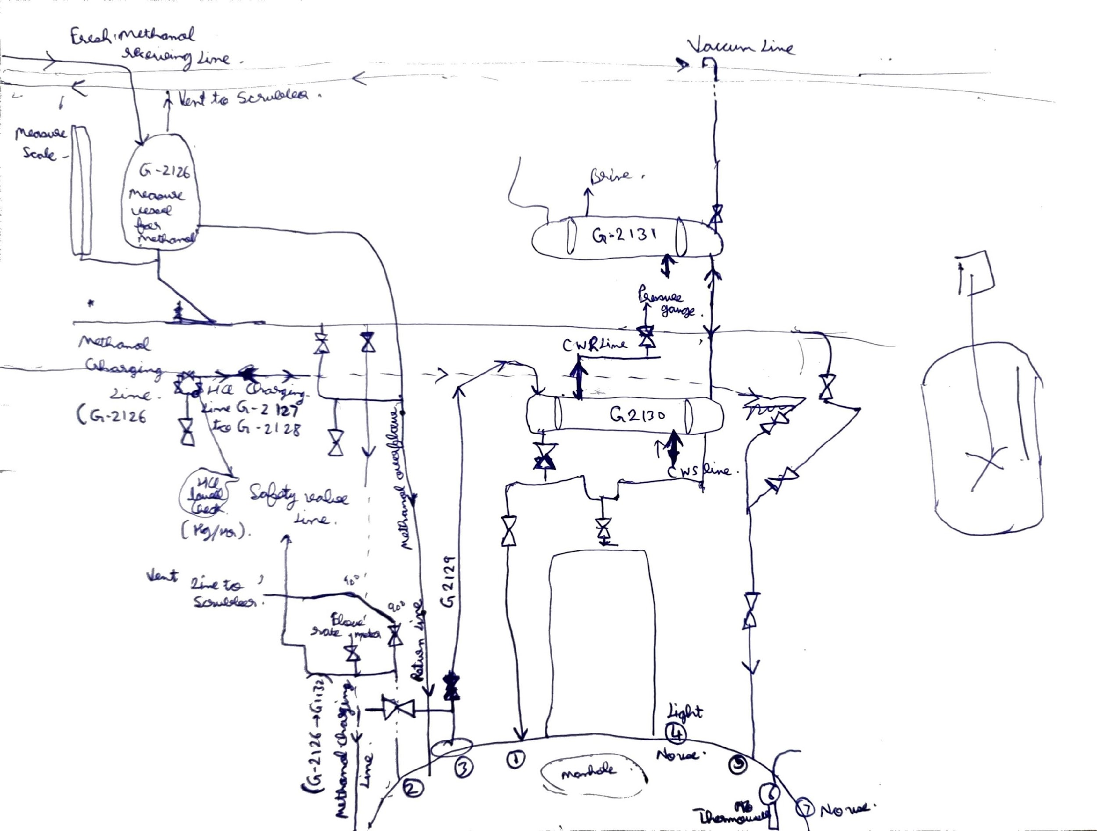

**P&ID Development:** Using specialized software, I proceeded to develop the P&ID. This involved translating the rough diagram into a detailed digital format, incorporating symbols, labels, and annotations to accurately depict the piping systems, equipment, instruments, and connections of the G-2128 reactor MSGL.

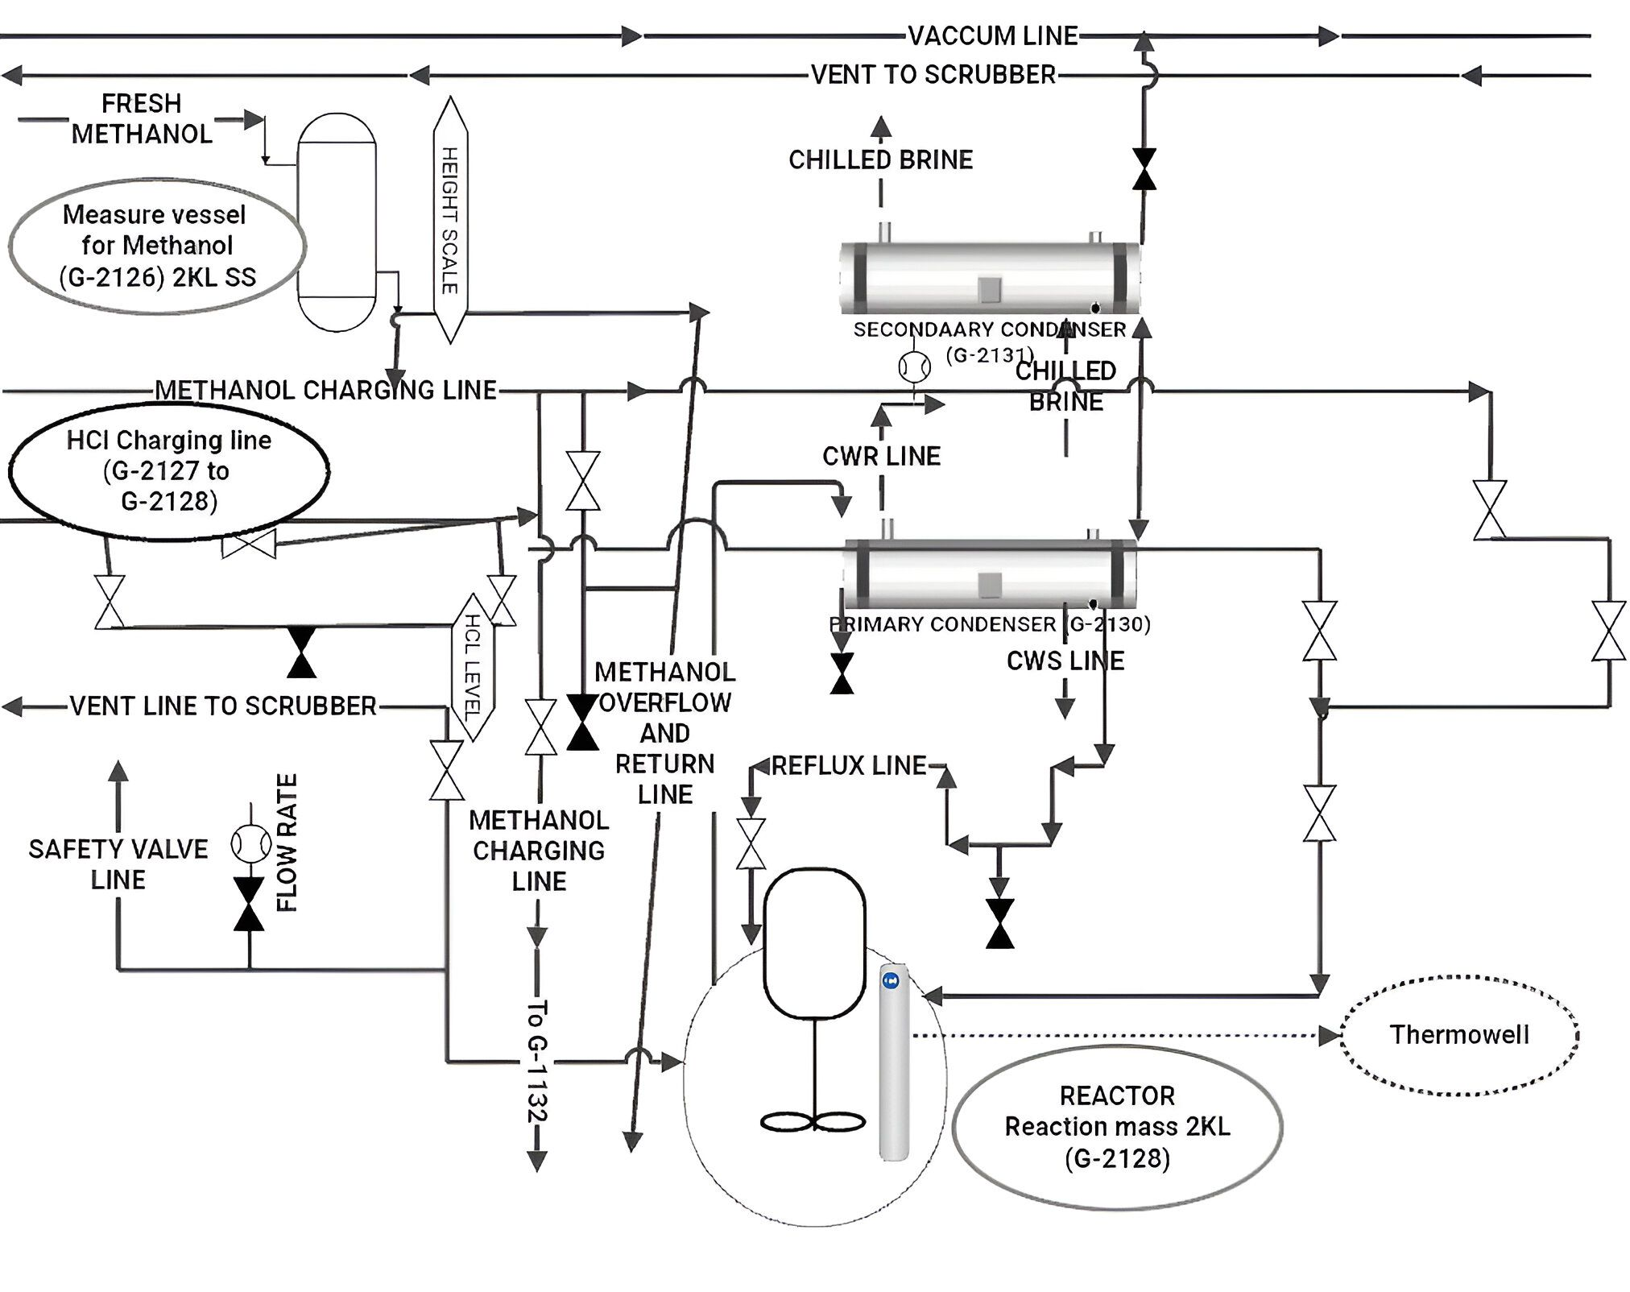

**Challenges Faced**

**Complexity of Systems:** The interconnected nature of the reactor's piping systems posed a challenge in accurately mapping all connections and ensuring consistency throughout the P&ID.

**Symbol Standardization:** Ensuring adherence to industry standards and plant-specific symbol conventions required careful attention to detail to avoid misinterpretation or errors in the P&ID.

**Software Proficiency:** Acquiring proficiency in the P&ID software to effectively utilize its features for creating a clear and comprehensive diagram was a learning curve.

**Insights and Learnings**

**System Understanding**: Through this project, I deepened my understanding of the operational dynamics of chemical reactors and the critical role of P&IDs in ensuring process safety and efficiency.

**Importance of Detail Orientation**: The project emphasized the importance of meticulousness in capturing even the smallest details in P&IDs to facilitate accurate plant operations and maintenance.

**Collaboration and Communication:** Effective communication with engineers and operators was crucial for validating the accuracy and usability of the P&ID, highlighting the importance of teamwork in industrial projects.

**Observations**

**Integration with Other Systems:** The G-2128 reactor MSGL interacts with multiple auxiliary systems, underscoring the need for comprehensive integration and coordination in P&ID development.

**Safety and Compliance:** Incorporating safety features and compliance with regulatory standards were integral aspects of the P&ID design, ensuring adherence to best practices in process industry operations.

**Technical Aspects**

**Symbol Selection:** Choosing appropriate symbols for valves, instruments, pumps, and other components ensured clarity and consistency in the P&ID.

**Annotation and Labels:** Clear labelling of all components and connections helped in understanding the flow paths and operational dependencies within the reactor system.

**Conclusion**

Creating the P&ID for the G-2128 reactor MSGL was a valuable learning experience that enhanced my technical skills, system understanding, and proficiency in industrial diagramming software. This project underscored the importance of accuracy, collaboration, and adherence to standards in industrial process design. Moving forward, the insights gained will significantly contribute to my professional development in the field of chemical engineering.

# PROJECT- 4: Reducing Distillation Timescale

Detailed Calculation:

Google:  
<https://docs.google.com/spreadsheets/d/1PR8rCm4jbcZjyKOy5ZkQzTY81QnnxTXw/edit?usp=sharing&ouid=112061776078456726353&rtpof=true&sd=true>

Excel:

<https://1drv.ms/x/c/ef8cc20df54f4245/ESl4GBr8Nv9KmAXa1lezIfYBC_nkTtjY_tFYfHGIt0a_KQ?e=hj8O7y>

**Introduction:**

The objective of this report is to explore strategies and solutions aimed at reducing the timescale of the distillation process in order to improve overall efficiency and throughput. Distillation is a critical operation in our plant, and optimizing its timescale can lead to significant cost savings and operational benefits.

**Current Challenges**

* Long Distillation Times: The current distillation process takes longer than desired, impacting production efficiency and throughput. It takes 8 hours to complete the distillation process, by suggested changes we can bring it down to 4 hours.
* Energy Consumption: High energy consumption associated with prolonged distillation cycles adds to operational costs.

**Proposed Solutions**

The following solutions are proposed to reduce the distillation timescale:

**Optimize Heat Transfer Efficiency:**

* Enhance Internal Heat Transfer Surfaces: Improve the vessel's internal heat transfer surfaces by considering modifications like internal coils, baffles, or enhanced surface materials to increase heat transfer efficiency.
* Increase Steam Flow Rate: Enhance the steam flow rate into the vessel to increase the boil-up rate. This accelerates the vaporization process and reduces distillation cycle times. Ensure steam line sizing is adequate to handle increased flow without causing pressure drops.
* External Heat Exchanger: Install an external heat exchanger to pre-heat the feed before it enters the vessel. This reduces the energy required within the vessel and speeds up the distillation process.

**Process Optimization:**

* Adjust Feed Rate and Temperature: Optimize feed rate and temperature control parameters to maximize the efficiency of the distillation process within the vessel. Monitor and adjust these parameters to minimize residence time and improve throughput.
* Uniform Feed Distribution: Ensure uniform distribution of feed across the vessel to utilize the entire heated surface area effectively and improve overall efficiency.

**Equipment Upgrades:**

* Condenser and Cooling System: Upgrade the condenser to improve heat removal efficiency and enhance cooling systems to maintain optimal operating temperatures within the vessel.
* Vapour and Collection Lines: Optimize vapour and collection line designs to minimize pressure drops and ensure smooth operation, thereby reducing the time vapours spend in the vessel.

**Automation and Monitoring:**

* Automate Process Controls: Implement automation systems to precisely control steam flow rates, temperature, and other critical parameters. Automation reduces variability and enhances consistency in distillation operations.
* Real-Time Monitoring: Install sensors and monitoring systems to track temperature profiles, pressure, and other relevant parameters in real-time. Use this data to optimize operations continuously.

**Energy Efficiency Measures:**

* Heat Recovery Systems: Integrate heat recovery systems to capture and reuse waste heat from the distillation process, reducing overall energy consumption and operational costs.
* Insulation Upgrades: Improve insulation around the vessel and associated piping to minimize heat loss and improve overall thermal efficiency.

**Implementation Plan**

* Feasibility Assessment: Conduct a detailed feasibility study for each proposed solution, considering technical feasibility, cost implications, and potential benefits specific to vessel-based distillation.
* Engineering Design: Develop detailed engineering designs and specifications tailored to vessel configurations for equipment upgrades and process optimizations.
* Pilot Testing: Implement pilot tests for selected solutions within vessel-based distillation setups to validate performance improvements and identify operational challenges.
* Full-Scale Implementation: Roll out approved solutions across the vessel distillation process, ensuring comprehensive training and support for plant operators.
* Monitoring and Evaluation: Establish metrics and performance indicators to monitor the effectiveness of implemented solutions in vessel-based distillation. Continuously optimize processes based on real-time data and feedback.

**Conclusion**

Implementing these targeted strategies for vessel-based distillation will effectively reduce distillation timescale, enhance operational efficiency, and achieve cost savings in your pharmaceutical plant. By focusing on optimizing heat transfer, upgrading equipment, and leveraging automation suitable for vessel setups, your plant can improve productivity and competitiveness in the industry.

**Recommendations**

* Immediate Actions: Prioritize enhancements to internal heat transfer surfaces and steam flow rates to quickly reduce distillation cycle times in vessel-based operations.
* Long-term Strategy: Foster a culture of continuous improvement and explore advanced technologies relevant to vessel-based distillation setups.
* Collaboration: Consider collaborating with technology providers and industry experts to leverage specialized solutions for vessel-based distillation optimization.

This approach will help streamline distillation processes specifically tailored to vessel-based operations, contributing to overall operational excellence in your pharmaceutical manufacturing facility.

# Departments at Atul Limited

**Production Department:**

* Responsible for manufacturing products as per production schedules.
* Operates machinery and processes to convert raw materials into finished goods.
* Works closely with the Planning Department to ensure production targets are met.
* Collaborates with QC for in-process and final product quality checks.
* Receives scaled-up processes from the Pilot Plant for full-scale production.

**R&D (Research and Development):**

* Conducts research to innovate and improve existing products or develop new ones.
* Divided into Development and Analytical paths.
* PH R&D focuses on API and Phosgene intermediates.
* Maintains Phosgene TLV value under 0.1.
* Performs initial testing and development in the Kilo Lab using small-scale quantities.
* Collaborates with the Pilot Plant for scaling up successful formulations or processes.
* Business department requests R&D to develop products according to market needs.

**QA (Quality Assurance):**

* Establishes and maintains quality standards and procedures.
* Ensures compliance with regulatory requirements and company policies.
* Works with Production to implement quality control measures.
* Provides support to production for product development and validation.

**QC (Quality Control):**

* Conducts testing and analysis of raw materials, intermediates, and finished products.
* Works closely with Production to monitor process parameters and product quality.
* Collaborates with QA to ensure adherence to quality standards and regulatory requirements.

**Technology Department:**

* Manages technology transfer and process improvements.
* Provides technical expertise and support to Production and R&D.
* Collaborates with Engineering for the implementation of new technologies.

**Engineering Department:**

* Responsible for maintenance and upkeep of plant equipment and facilities.
* Executes preventive and corrective maintenance programs.
* Supports Production by ensuring machinery uptime and reliability.
* Collaborates with Technology for equipment upgrades and installations.

**Safety Department:**

* Ensures adherence to safety protocols and regulations.
* Conducts safety audits and risk assessments.
* Collaborates with Engineering for implementing safety measures and training programs.

**Procurement Department:**

* Manages sourcing and procurement of raw materials and services.
* Works closely with Production to ensure timely availability of materials.
* Collaborates with Finance for budgeting and cost control.

**Production and Planning Department:**

* Plans and schedules production activities based on demand forecasts.
* Coordinates with Procurement for raw material availability.
* Works with QC for quality checks and with Engineering for maintenance schedules.
* Implements processes scaled up from the Pilot Plant for commercial production.

**Finance:**

* Manages financial planning, budgeting, and cost control.
* Collaborates with Procurement for vendor management and payments.
* Supports other departments in financial analysis and decision-making.

**Additional Facilities:**

**Kilo Lab:**

* Conducts small-scale testing and development of new products or processes after initial R&D.
* Produces test batches typically in kilogram quantities for feasibility studies and initial quality testing.
* Interfaces closely with R&D and QC for validation and evaluation of experimental processes and formulations.

**Pilot Plant:**

* Scales up successful processes and formulations from the Kilo Lab to larger quantities.
* Conducts trials and tests manufacturing feasibility before full-scale production.
* Collaborates with R&D, Production, and Engineering for process optimization and equipment validation.

**Interconnections:**

* **R&D and Kilo Lab:** R&D performs initial testing and development in the Kilo Lab, validating new formulations and processes before scaling up.
* **Kilo Lab and Pilot Plant:** Kilo Lab transfers successful formulations to the Pilot Plant for scale-up, ensuring processes are feasible for commercial production.
* **Pilot Plant and Production:** Pilot Plant provides scaled-up processes and formulations to Production for full-scale manufacturing, ensuring continuity from development to commercialization.
* **QC/QA and Production:** QC conducts testing and validation at various stages from the Kilo Lab to full-scale production, ensuring quality standards are maintained throughout.

These departments and facilities work synergistically to streamline operations, ensure product quality, foster innovation, and facilitate efficient scaling of processes at Atul Limited

# 8 Report: Study Intelligent Plant Framework (IPF) Implementation at Atul Ltd.

**1. Project Overview and Objectives**

The Covacsis Technologies Intelligent Plant Framework (IPF) implementation at Atul Ltd.'s BLR Plant represents a significant step towards digital transformation in manufacturing. This project aligns with the broader Industry 4.0 movement, which aims to create "smart factories" through the integration of digital technologies.

**Key objectives:**

**a) Real-time data acquisition:**

This involves collecting data from various sources across the plant floor in real-time. Instead of relying on periodic manual readings or end-of-shift reports, the system continuously gathers data from machines, sensors, and control systems. This provides an up-to-the-minute view of plant operations, allowing for quicker responses to issues and more accurate decision-making.

**b) Enhanced data transparency and process adherence:**

By making real-time data easily accessible to relevant stakeholders, the system promotes transparency across departments. Managers and operators can see the current status of production, machine performance, and key metrics at a glance. This visibility helps ensure that processes are followed correctly and any deviations are quickly identified and addressed.

**c) Automated reporting:**

Automating the generation of reports saves time and reduces the potential for human error. Instead of staff spending hours compiling data into reports, the system can generate these automatically at set intervals or on-demand. This frees up personnel to focus on more value-added activities and ensures consistent, timely reporting.

**2. Scope of Implementation**

The project covers 10 key machines/devices in the BLR Plant:

* 4 Reactors (R1, R2, R3, R4)
* 4 Distillation Columns (DC1, DC2, DC3, DC4)
* 2 Filtration Columns (FC1, FC2)

For each machine, the system tracks a comprehensive set of KPIs and parameters:

* Machine runtime and downtime: Tracks how long machines are operating or idle, helping identify inefficiencies.
* Production metrics (batch and daily): Monitors output on both a per-batch and daily basis.
* Machine availability and performance: Measures how often machines are ready for use and how well they perform when running.
* Quality metrics: Tracks product quality parameters to ensure consistency and identify quality issues early.
* OEE (Overall Equipment Effectiveness): A composite metric combining availability, performance, and quality.
* Batch cycle time: Measures how long each production batch takes, helping identify bottlenecks or inefficiencies.
* Resource consumption (raw materials, power, steam, water): Monitors usage of inputs to track efficiency and identify potential waste.
* MTTR (Mean Time To Repair) and MTBF (Mean Time Between Failures): Key maintenance metrics to assess equipment reliability and maintenance effectiveness.
* Various process parameters: Specific to each machine, these could include temperature, pressure, flow rates, etc.

**3. Technical Solution: Intelligent Plant Framework (IPF)**

The IPF is a comprehensive solution designed to integrate data from various sources and provide actionable insights:

**a) Real-Time Data Acquisition:**

* PLC/DCS Integration: The system connects directly to Programmable Logic Controllers (PLCs) and Distributed Control Systems (DCS) to capture machine data in real-time.
* Operator Inputs: Custom screens allow operators to input data that can't be automatically captured, such as reasons for downtimes or quality observations.
* Sensor Integration: Additional sensors can be integrated to capture data available from existing control systems.

**b) Data Processing and Analysis:**

* Data Consolidation: The system brings together data from disparate sources into a single platform, creating a unified view of operations.
* KPI Calculation: Raw data is processed to calculate higher-level KPIs in real-time.
* Historical Analysis: The system stores historical data, allowing for trend analysis and pattern recognition over time.

**c) Visualization and Reporting:**

* Customizable Dashboards: Users can create and customize dashboards relevant to their roles, from operator-level machine status views to management-level performance overviews.
* Real-time Trending: The system can display live trends of key parameters, allowing for immediate identification of issues or anomalies.
* Automated Reports: Regular reports (shift, daily, weekly) are generated automatically, ensuring consistent and timely information dissemination.

**d) Alerts and Notifications:**

* Threshold-based Alerts: The system can trigger alerts when parameters exceed predefined thresholds, allowing for quick response to potential issues.
* Multi-channel Notifications: Alerts can be sent via multiple channels (SMS, email, in-app notifications) to ensure they reach the right people quickly.

**4. Implementation Process**

The implementation follows a structured approach to ensure smooth deployment:

**a) Detailed Mapping (1 week):**

This crucial first step involves a thorough assessment of the plant's current systems and processes. It includes:

* Identifying all data sources (machines, sensors, existing systems)
* Mapping out desired KPIs and how they relate to available data
* Understanding current workflows and how they might be impacted or improved

**b) Hardware Procurement (3-4 weeks):**

Based on the mapping, necessary hardware is identified and procured. This typically includes:

* Local Interpreting Units (LIUs) for data collection
* Network infrastructure upgrades if needed
* Any additional sensors required

**c) Integration and Configuration:**

This phase involves the physical installation of hardware and the configuration of the IPF software:

* Installing LIUs and connecting them to data sources
* Configuring data collection parameters
* Setting up the IPF software, including defining KPIs, creating initial dashboards, and setting up user accounts

**d) Testing and Validation:**

Rigorous testing ensures the system is working as intended:

* Verifying data accuracy by cross-checking with existing systems
* Validating KPI calculations
* Testing alert mechanisms
* Performing user acceptance testing with key stakeholders

**e) Training and Go-Live:**

* Conducting training sessions for different user groups (operators, managers, IT support)
* Performing a staged go-live, often starting with a pilot area before full rollout
* Providing initial hand-holding support as users adapt to the new system

**5. Architecture**

The IPF architecture is designed for scalability and flexibility:

**a) Local Interpreting Units (LIUs):**

* Act as edge devices, collecting data close to the source
* Perform initial data filtering and processing to reduce network load
* Ensure data collection continues even if network connectivity is temporarily lost

**b) Cloud-Hosted Analytics Platform:**

* Provides scalable computing power for data processing and analytics
* Enables easy access from anywhere with an internet connection
* Offers built-in redundancy and disaster recovery capabilities

**c) Web-Based Access:**

* Allows users to access the system from any device with a web browser
* Eliminates the need for software installation on user devices
* Ensures all users are always accessing the latest version of the interface

**6. Key Features and Benefits**

**a) Real-time Monitoring:**

* Provides immediate visibility into plant operations, allowing for quicker decision-making
* Enables proactive issue identification rather than reactive problem-solving

**b) Customized Dash boarding:**

* Allows different user groups to focus on the metrics most relevant to their roles
* Improves information accessibility, reducing time spent searching for data

**c) Automated Reporting:**

* Saves significant time previously spent on manual report generation
* Ensures consistency in reporting and reduces the potential for human error

**d) Process Adherence:**

* Helps enforce standard operating procedures by highlighting deviations in real-time
* Improves product quality and consistency by ensuring processes are followed correctly

**e) Data-Driven Decision Making:**

* Provides a factual basis for decisions, reducing reliance on gut feel or outdated information
* Enables more accurate production planning and resource allocation

**f) Efficiency Improvements:**

* Identifies bottlenecks and inefficiencies that might not be apparent without data
* Supports continuous improvement initiatives by providing clear, measurable data

**7. Future Roadmap**

The current implementation lays the groundwork for more advanced capabilities in Phase 2:

**a) AI/ML Prediction Models:**

* Will use the data collected in Phase 1 to build predictive models
* Could include predictive maintenance, yield optimization, or energy consumption forecasting

**b) Alert Response Management:**

* Will create a structured system for responding to and tracking the resolution of issues identified by the system
* Aims to improve accountability and ensure consistent problem-solving approaches

**c) Process Optimization:**

* Will use the rich dataset to identify opportunities for lean improvements
* Could include energy optimization, waste reduction, or cycle time improvements

**d) Digital Work Instructions:**

* Will move paper-based procedures into the digital realm
* Aims to improve consistency in task execution and provide easier access to up-to-date procedures

This implementation represents a significant step forward in Atul Ltd.'s digital transformation journey. It lays the foundation for data-driven operations and opens up numerous opportunities for further optimization and innovation in the future.

**Some examples of Dashboard:**

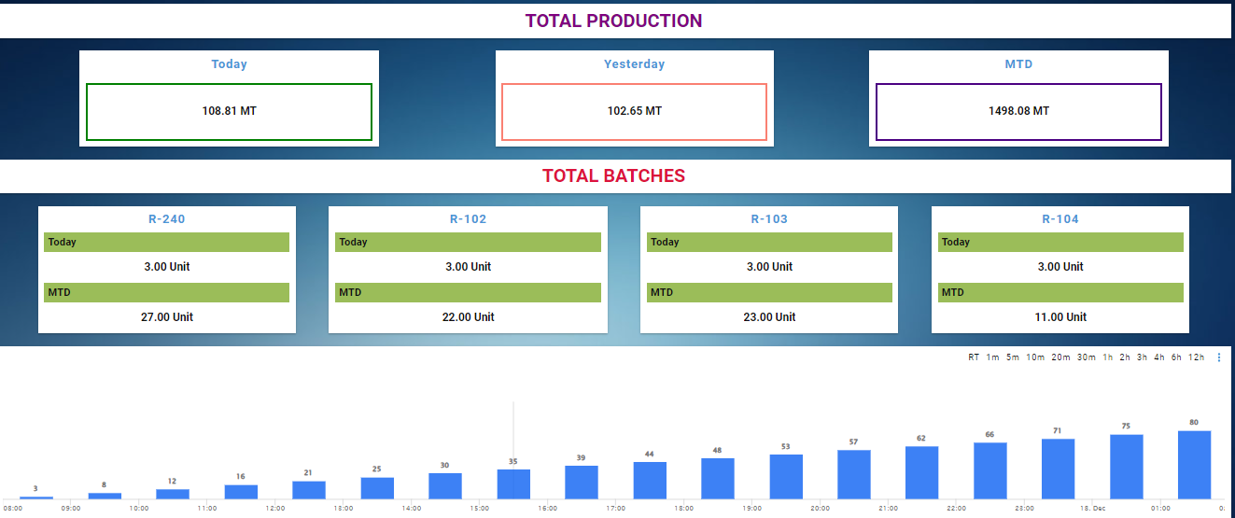

**In process QC data:**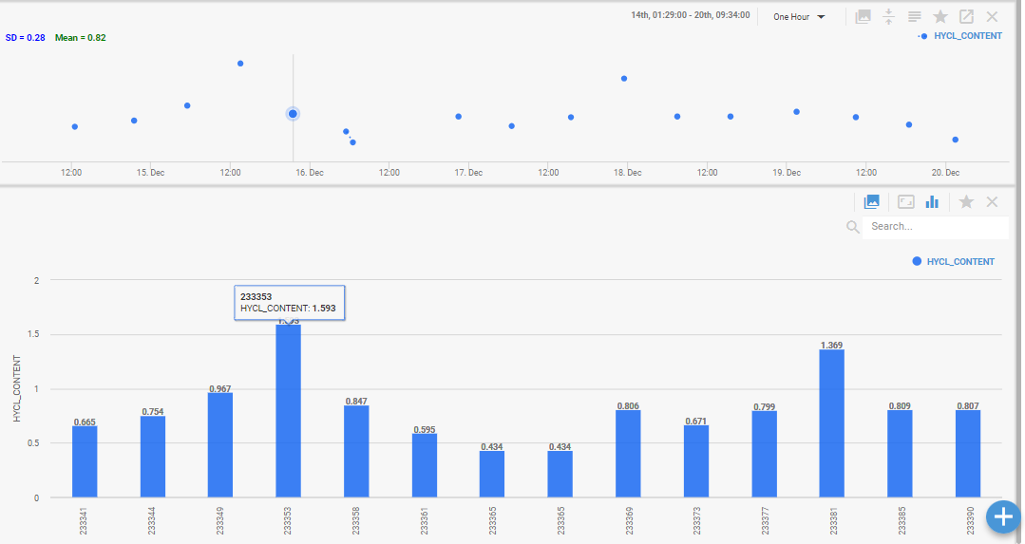

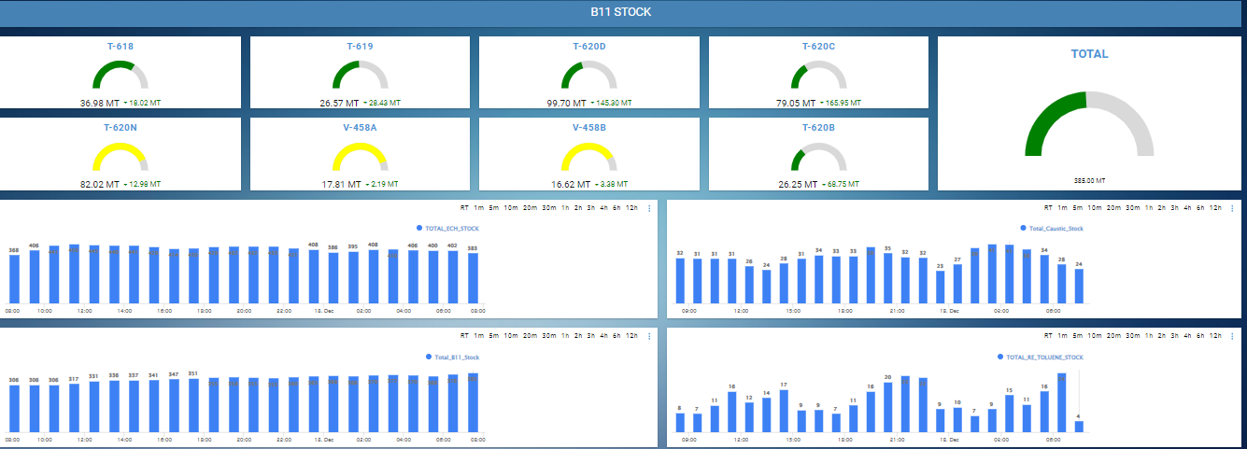

**Production Vs Consumption:**

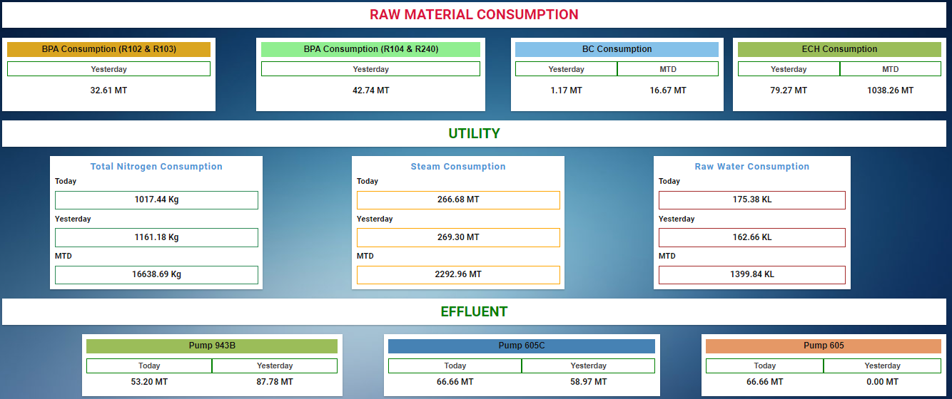

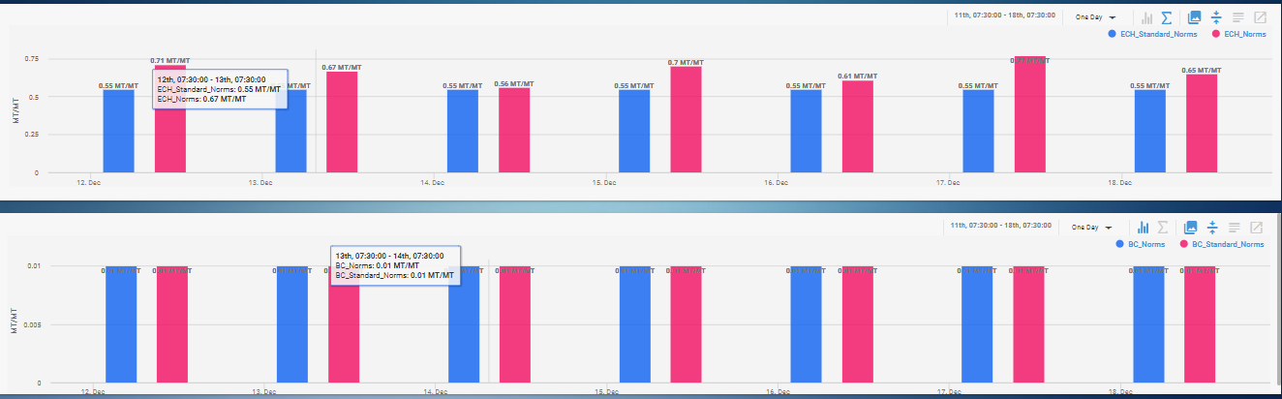

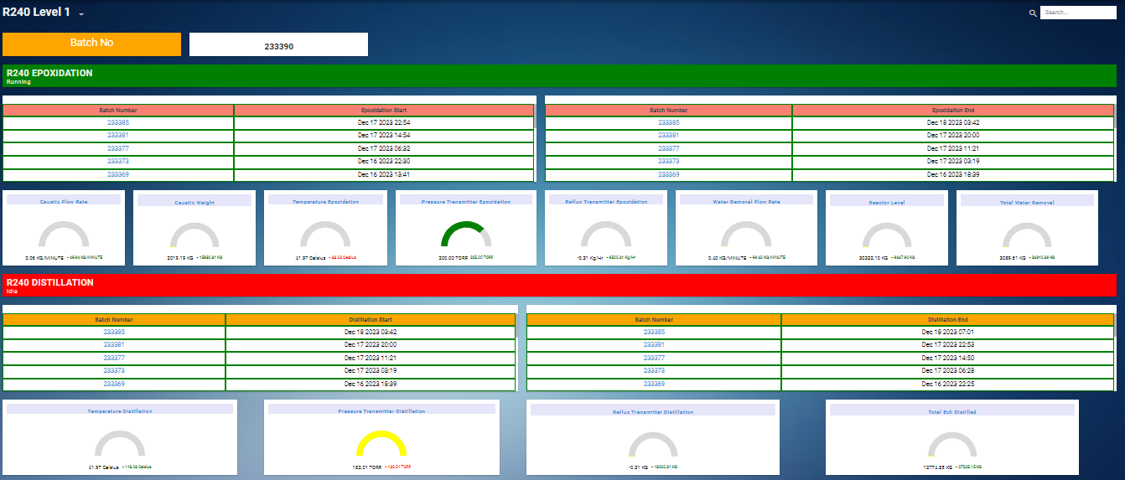

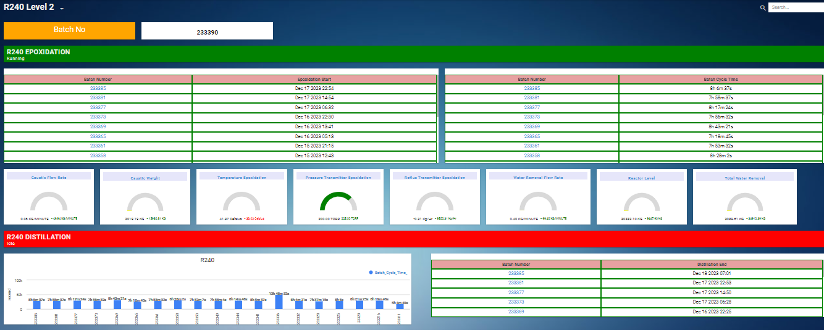

**Golden Batch:**

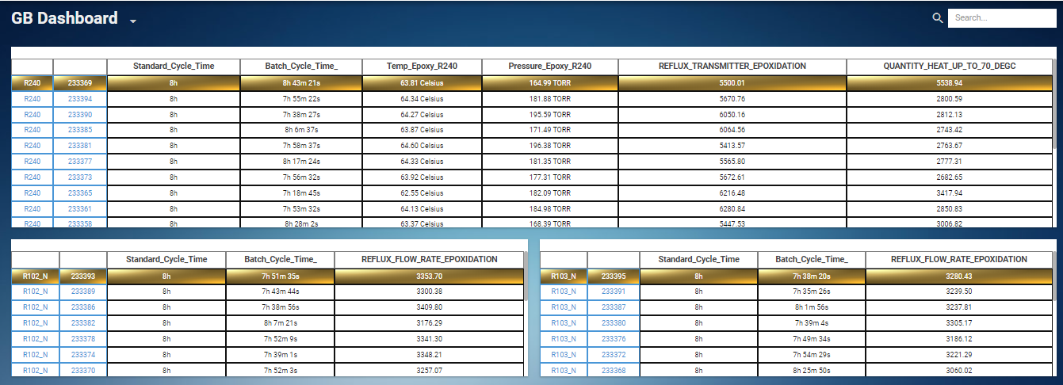

**EMS:**

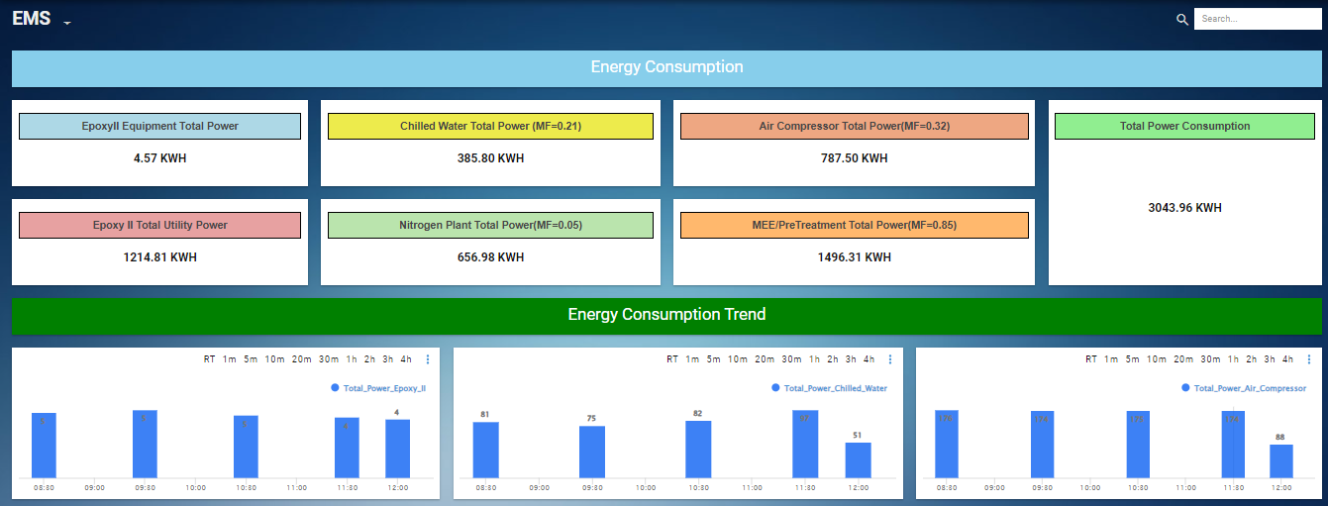

**Automated Logsheet:**

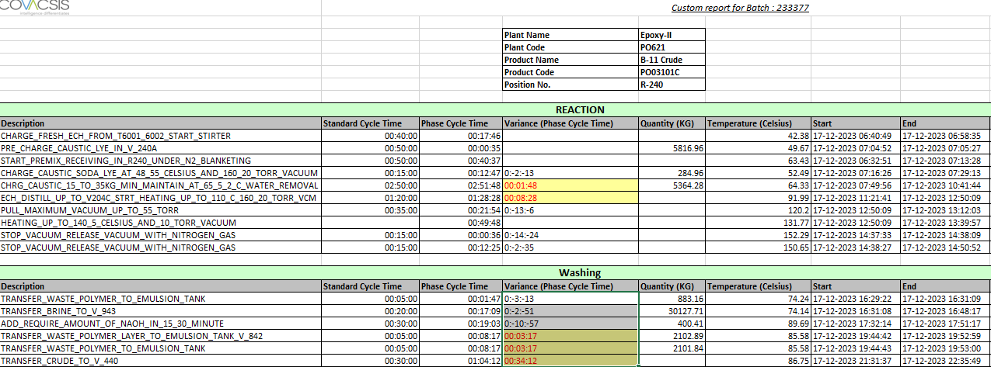

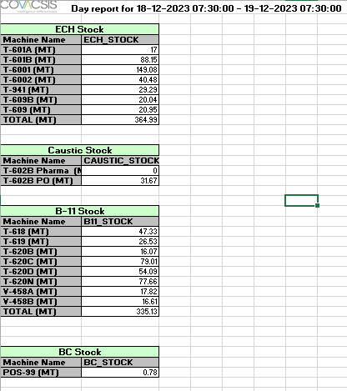

# 9. BTG proposal for Atul's 100 TPD Caustic Plant digital optimization project:

**Aim:**

BTG is proposing to implement an integrated digital solution at Atul Chemicals' 100 TPD Caustic Plant to reduce operational costs and improve process efficiency. The solution includes:

1. DataPARC software for data visualization, analysis, and process monitoring

2. MACS Advanced Process Controls (APC) Suite

**Key Benefits:**

* Improved final product quality and reduced variability
* Reduced process variability
* Reduced raw material and energy consumption
* Estimated annual savings of over €400,000

**Main Components:**

**1. DataPARC Software**

DataPARC is a comprehensive Process Information Management System that includes:

* Data collection from control systems
* Long-term data storage in a historian database
* Data visualization and analysis tools
* Integration with other databases and systems

**Key Features:**

* Real-time and historical data trending
* Process analytics and modeling capabilities
* KPI dashboards and reporting
* Alarm management
* Mobile/web access

The system is designed to provide insights for process optimization and real-time decision making across all levels of the organization.

**2. MACS Advanced Process Control Suite**

MACS is BTG's proprietary Model Predictive Control (MPC) software for advanced process control. Key components include:

* MACSsuite: Core MPC control software
* MACSsoftsensor: For estimating unmeasured process variables
* MACSalarm: For monitoring and alerting
* MACSmonitoring: For performance monitoring and reporting

The MACS system will automatically manage process variables between stages to optimize chemical usage, reduce quality variability, and minimize energy consumption.

**Implementation Approach:**

The project will follow a staged implementation approach:

1. Process Analysis & Instrumentation Review

2. Process Testing & Data Collection

3. Process Modeling

4. Controller Design & Simulation

5. Controller Commissioning

6. Operator Training

7. Performance Monitoring & Optimization

**Key Focus Areas:**

* Minimize steam usage in CCU
* Optimize electrical usage in cells
* Stabilize caustic concentration

**Infrastructure Requirements:**

* Servers for dataPARC and MACS systems
* OPC interfaces to DCS and other control systems
* Network connectivity between systems
* Remote access for BTG support

**Cool Tech Aspects:**

**1. Multi-variable Model Predictive Control**

* Uses dynamic process models to predict and optimize future control actions
* Handles complex process interactions and constraints

**2. Soft Sensors**

* Uses available measurements to estimate difficult-to-measure quality variables
* Provides real-time quality estimates for tighter control

**3. Statistical Process Control Integration**

* Built-in SPC/SQC capabilities for monitoring process stability

**4. Advanced Data Visualization**

* Interactive dashboards and trends
* Playback capabilities for historical analysis

**5. Mobile/Web Access**

* Allows monitoring of plant performance from anywhere

**Learning Opportunities:**

As an intern, this project offers exciting opportunities to learn about:

1. Advanced process control techniques

2. Big data analytics in manufacturing

3. Industrial IoT and connectivity

4. Process modeling and optimization

5. Human-machine interface design

**Questions to Explore:**

1. How does model predictive control differ from traditional PID control?

2. What kinds of process insights can be gained from long-term data analysis?

3. How do soft sensors work and what are their limitations?

4. What are the challenges in implementing advanced controls in a chemical plant?

5. How can data visualization improve operational decision making?

In conclusion, this project represents a significant step towards Industry 4.0 for Atul's caustic plant. It combines advanced process control with modern data analytics to drive operational excellence. As an intern, diving deep into these technologies could provide valuable skills for a future career in process automation and optimization

# Acknowledgments:

I extend my sincere thanks to **Mr. Jayesh Patel** and the entire **team of Atul Ltd.** for their guidance, support, and valuable insights throughout this internship project.

Their expertise and collaboration were instrumental in the successful completion of this Internship.

# References:

* **Google Images:** Accessed for visual references related to [specific topic or concept].
* **Wikipedia:** Used for general background information on [relevant subject].
* **Pharma Calculations:** Referenced for detailed calculations related to [specific aspect of pharmaceutical processes].
* **BTG Report:** Utilized for insights and data from [brief description of the report content].
* **Berth Lab Report:** Cited for experimental findings and data on [relevant research topic].
* **Covacsis Report:** Used for analytics and operational insights regarding [specific area covered in the report].
* **Atul Ltd. Team:** Learning and guidance received from the team at Atul Ltd. on [specific aspects of the project or topic].
* <https://www.thermopedia.com/content/1150/>

**THANK YOU.**

Kanishq Sahu

[2022chb1049@iitrpr.ac.in](mailto:2022chb1049@iitrpr.ac.in)

9009730530